Create user and user group

Sign in the AWS Management Console
- Open you browser and go to https://aws.amazon.com
- Click Sign in to the Console.
- Select Root user, enter the root email and password
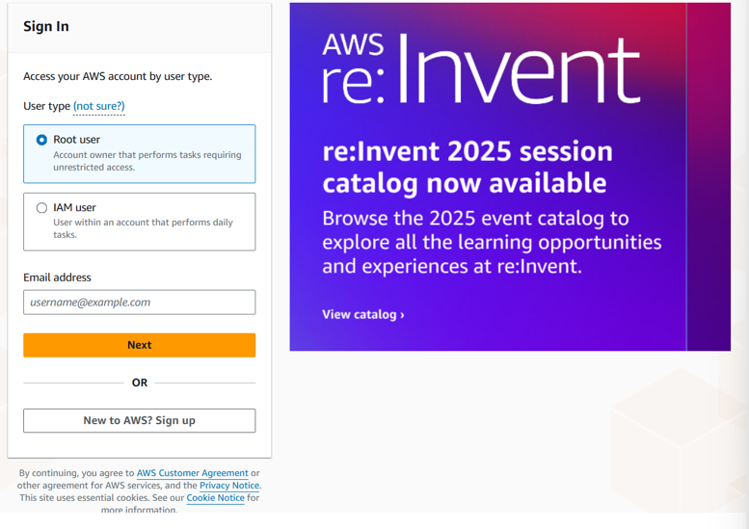

Create an IAM user with Console access
1. In the AWS Console search bar, type IAM and open IAM (Identity & Access Management).
2. In the left navigation, click Users.
3. Click Add users (or Create user).
4. User name: type the desired user name (Azad)
5. Check Provide user access to the AWS Management Console (this enables console login).
Then select I want to create an IAM user. A password area will appear.
6. Choose Custom password.
7. Enter the password you want to assing.
8. Uncheck User must create a new password at next sign-in (this prevents the forced password change).

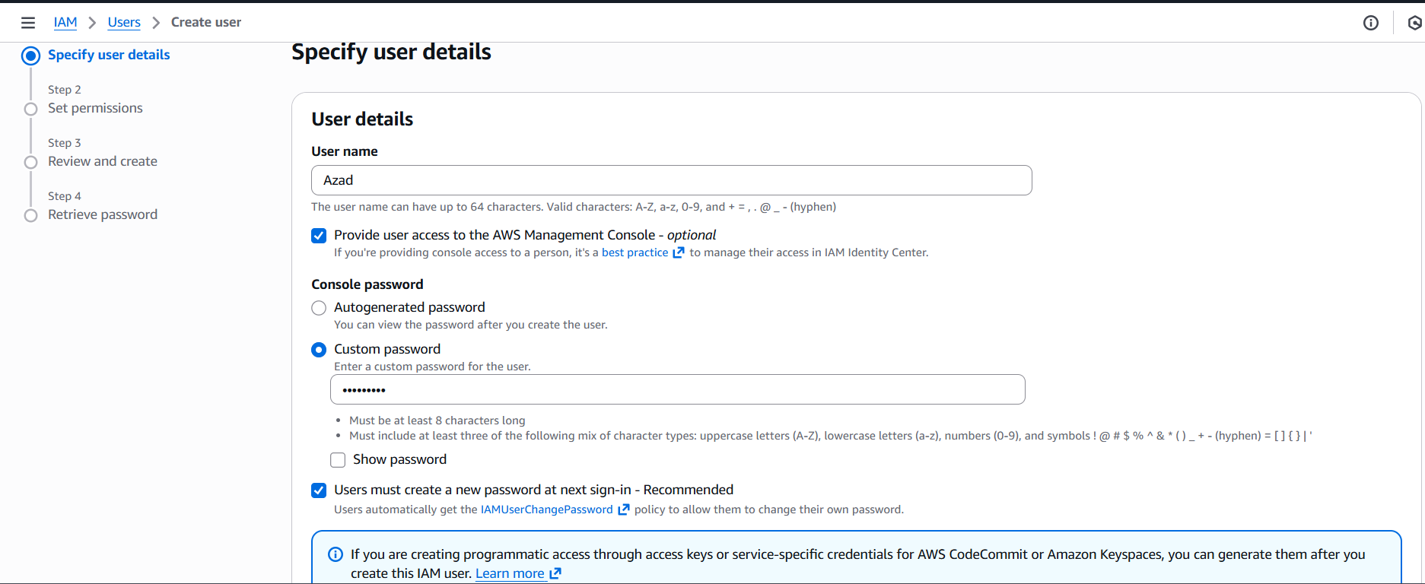

9. Set permissions (choose how this user gets permissions)
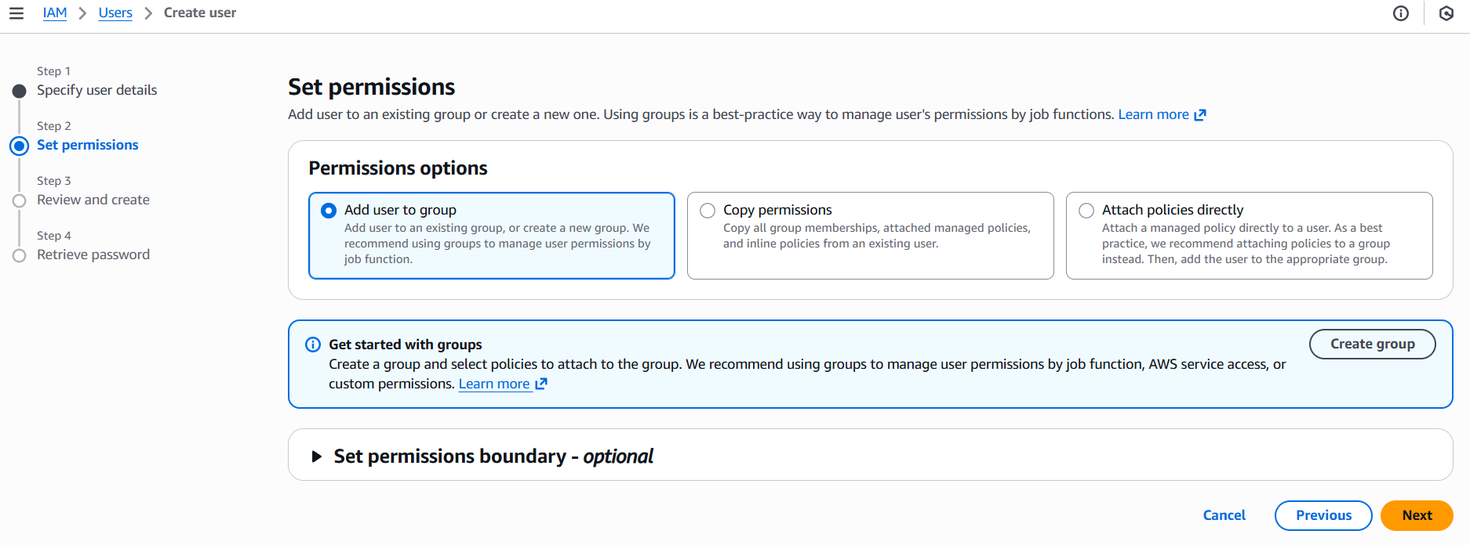
10. Review and create. Carefully review: Console access = Enabled, Password = Custom, Force password reset = Unchecked, and Permissions = selected group/policies.

11. Click Create user.
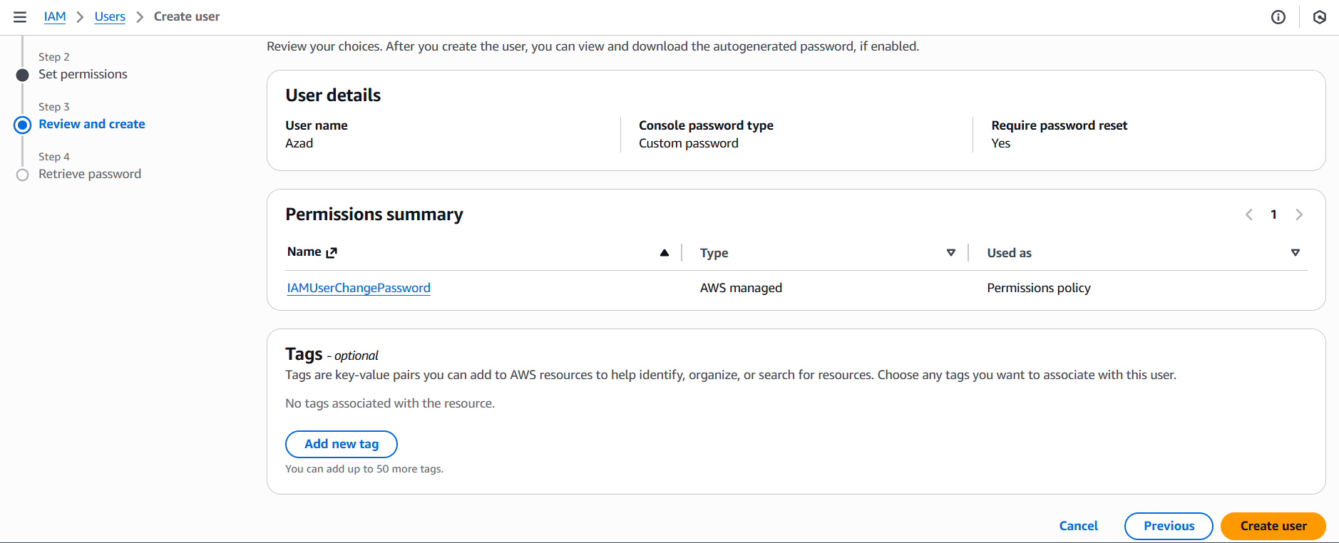
12. Save the results. User created successfully, download the .csv (if available) or copy the sign-in URL and username.
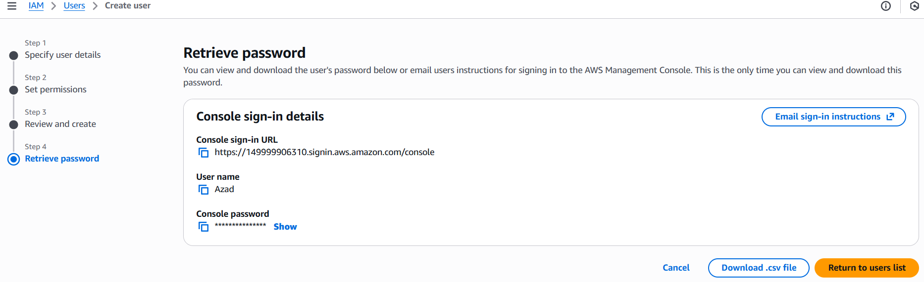

Create Multiple IAM Users in AWS
- Repeat Steps no 1 for three more users: User 1 → username: Azad, assign custom password User 2 → username: Kundan, assign custom password, uncheck forced reset. User 3 → username: Mohit, assign custom password, uncheck forced reset. User 4 → username: Raj, assign custom password, uncheck forced reset.
- 2. Each user will now have: IAM login credentials. Console access with your chosen password.
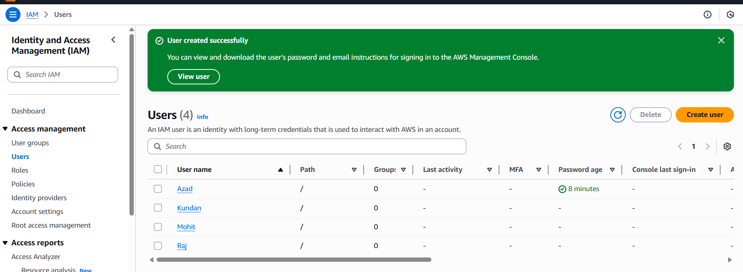

Create IAM User Groups And Add USERS
Create Group 1
1. Open IAM. In the left navigation panel click User groups.
2. Click Create group.
3. Group name: Enter One.
4. Under Attach permissions policies → in the search box type Administrator Access . Check the box next to Administrator Access (this is the AWS managed policy that grants full admin). Click Next.
5. Add users: check User1(Azad) and User2(Kundan). Review, then click Create group.
6. After creation, click the group name to open its details and confirm Permissions and Users tabs show the attached policy and the two users.
7. Click Create User Group.
8. After Creating User Group One They Look Like
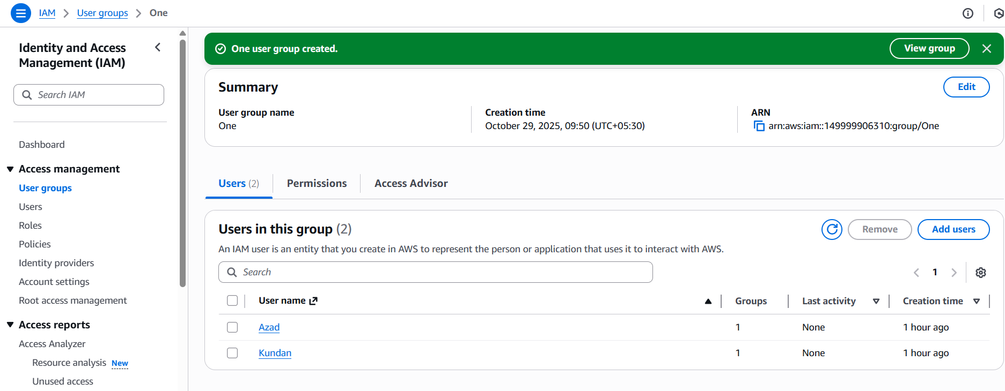

Create Group 2
1. In IAM → User groups click Create group again.
2. Group name: Enter Two (or preferred name).
3. Under Attach permissions policies search for AmazonEC2ReadOnlyAccess.
4. Check AmazonAppStreamReadOnlyAccess.
5. Click Next, then on the Add users page select User3(Mohit) and User4(Raj).
6. After Creating User Group Two They Look Like

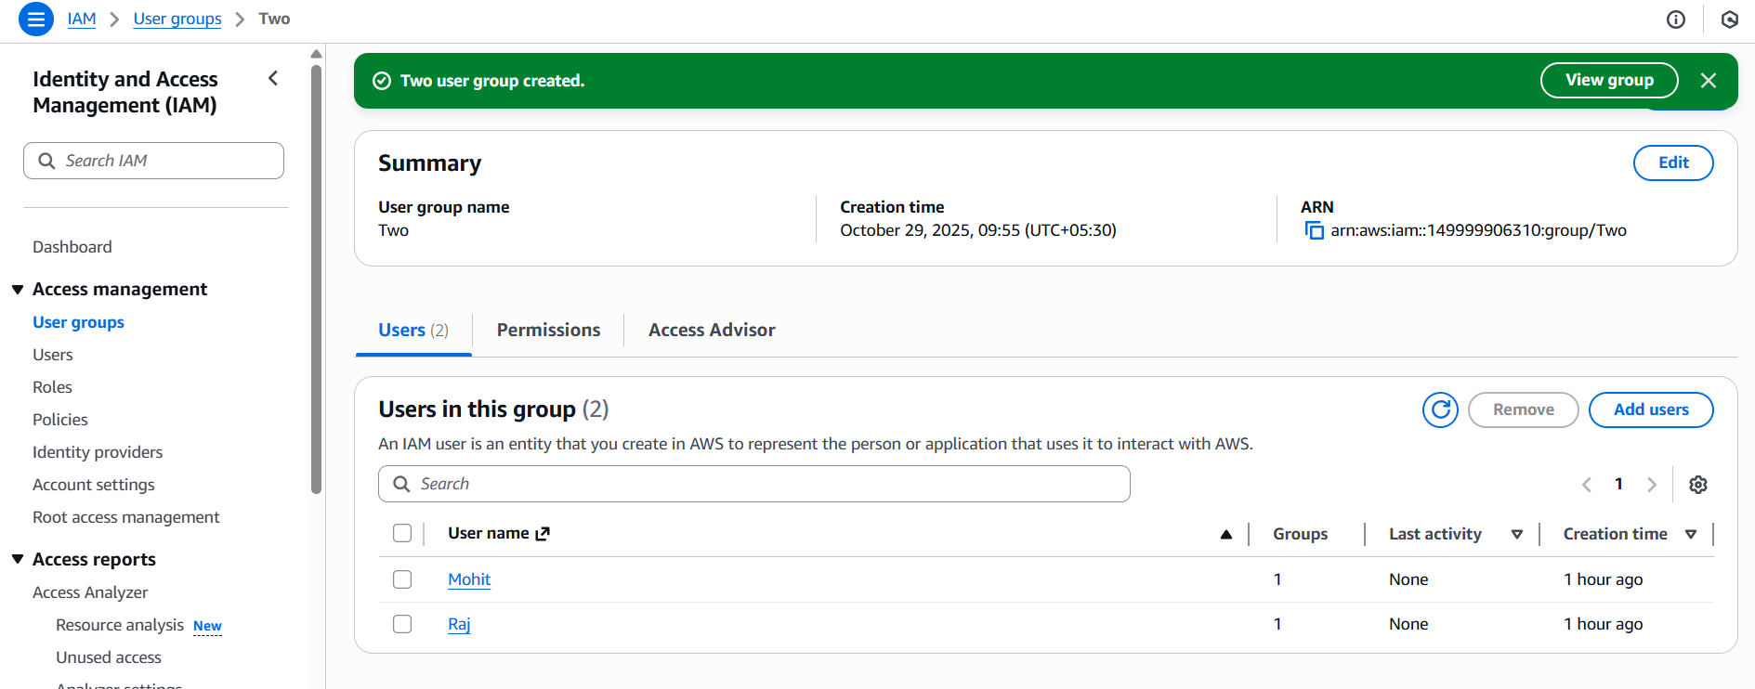

Create Group 3 And Merge group policies
1. Create group. Group name: Enter the group name Three.
2. Under Attach permissions policies, in the search box type AmazonS3FullAccess. Check the box next to AmazonS3FullAccess .
3. Click Next.
4. Add users select the existing users User2(Azad) and User3(Mohit).
5. Next: Review. Review the group name, attached policy and users, then click Create group.
To add AmazonS3FullAccess to an existing group and add users
• IAM → User groups → click the group name → Permissions → Attach policies → search AmazonAppFlowReadOnlyAccess → attach.
• Then Users → Add users → check User3(Azad) and User4(Mohit) → Add users.
6.. After Creating User Group Three They Look Like
